**“Acoustic Shadow Detection: Study and Statistics of B-Mode and Radiofrequency Data”**

**Detailed Response to Reviewers**

Dear all reviewers,

We sincerely thank you for taking the time to review our manuscript and provide input with your expertise. We found your comments insightful and completely constructive. In almost every case, the comments made resulted in a change in the manuscript that corrected inaccuracies, provided extra clarity for readers, or reinforced the concepts presented in the manuscript for acoustic shadow detection.

We have addressed every comment below, with our response and stated changes in the manuscript with the line number. Please note that two new figures have been added to the manuscript in response to the comments. We hope that you find the responses appropriate in addressing the comments and improving the manuscript.

Thank you again for your consideration.

Sincerely,

Ricky Hu

University of British Columbia Robotics and Control Laboratory

4090-2332 Main Mall

Vancouver, British Columbia, Canada

V6T 1Z4

Tel: +1-778-706-8875

Email: rhu@ece.ubc.ca

**Responses to Reviewer 1**

**1.**

**Reviewer’s Comment:**

General: Of course, a more throughout validation of the proposed method with clinical pathological cases would be required to state on the potential of the proposed method. Several typos were noticed, especially in Discussion, they must be corrected.

**Author’s Response:**

A subsection has been added to the discussion section to discuss the limitations of pathological applicability of these method, with the same additions as Comment 14. Typos have been addressed, similar to comments from Reviewer 3.

**Changes in Manuscript:**

Changes regarding pathological cases addressed in Comment 14. Grammatical changes presented at the end of this document in response to Reviewer 3.

**2.**

**Reviewer’s Comment:**

P6, L77: Justify the "multiplicative" nature of wave scattering interference. This is unexpected in linear acoustics.

**Author’s Response:**

We agree that “multiplicative” is not mathematically accurate in describing the summed contributions of the scatterers that cause speckle. The description of speckle has been changed.

**Change in Manuscript:**

**L80:** Changed “Speckle occurs due to multiplicative scattering of acoustic waves in a material, resulting in a granular appearance on the image.” to “Speckle occurs from interference of randomly distributed microscopic scatterers, resulting in a granular appearance on the image”.

**3.**

**Reviewer’s Comment:**

P6, L79: This is also incorrect: "B-mode image processing attempts to remove speckle". Speckle usually refers to the stochastic nature of B-mode images.

**Author’s Response:**

We agree the statement in the manuscript was inaccurate. Image processing in B-mode is acknowledged to not specifically aim to remove speckle. We do know that logarithmic compression and frequency-dependent attenuation are used by some image processing algorithms and these nonlinear transforms make it difficult to study the original speckle. To state this more accurately than the original manuscript, the statement has been changed.

**Change in Manuscript:**

**L87:** Changed “B-mode image processing commonly attempts to remove speckle, but speckle contains information of the acoustic interactions in tissue” to “to produce B-mode images, manufacturers often image enhancement algorithms, such as logarithmic compression, which nonlinearly alter speckle patterns. However, the original speckle pattern contains information of the acoustic interactions in tissue.”

**4.**

**Reviewer’s Comment:**

P6, L82: Can we really define the absence of signal in shadows as speckle? Speckle occurs to the constructive and destructive wave interferences; if there is no signal (background noise) can it be considered as speckle? Maybe but it could be relevant to talk about "random speckle", if it is a white Gaussian noise. It would be relevant to perform a review on ultrasound background noise statistical characteristics to clarify the nature of the "random speckle"; even though it is one of the objectives of your work to define the Nakagami pdf of random speckle in shadows. It has already been addressed in the "old" literature (probably not using the Nakagami modeling but likely Rayleigh pdf).

**Author’s Response:**

The comment promotes excellent discussion on what “speckle means in shadow region. We agree with the comment that if there is an absence of signal in shadow regions, there is no full “speckle” in the sense of granularity that visualizes the interference interactions between scatters that can be observed on a raw RF image. A clarification has been added that the differentiation in the shadow region or non-shadow regions is not by the speckle in each region but by the distribution of the scatterers. In the case of a non-shadow, we expect it to resemble ultrasonic speckle and in the case of the shadow, we expect a lack of ultrasonic speckle and be composed of electronic background noise instead. We acknowledge that this is different than work that, for instance, characterizes different types of speckle between lesions as the noise in shadows isn’t really a different “type” of speckle. Aysal et al. (2007) [1] developed a model for random ultrasound noise using the Rayleigh distribution similar to the speckle intuition used in our method, though that filter and most filters aim to target general tissue-like speckle. In images by Aysal et al. (2007), Rayeligh-like filtering in fetal images was successful in removing some granularity from areas of tissue and shadow (underneath a fetal skull). Although we expect white gaussian electronic noise to be present, there seems to be some contribution from “random speckle” which may be capable of being modelled by Rayleigh or Nakagami distributions to a limited extent. Investigating the noise in shadow regions by Nakagami analysis may still result some insight on where shadows start, even if a fully developed shadow doesn’t exhibit tissue-like speckle, as we still observed some speckle-like behavior at the boundary of shadows.

**Change in Manuscript:**

**L89:** Changed “Speckle can then characterize different regions, such as a region of tissue or a region of signal loss in a shadow.” to “By analyzing the RF signal distribution, we can statistically characterize the distributions in tissue compared to shadow regions. We expect tissue to resemble speckle modeled by known distributions and expect shadow to resemble different distributions, which may be a mixture of lessened speckle due to the signal loss and background electronic noise. Previous studies have attempted despeckling methods on images containing shadows (Aysal et al. 2007) [1] by using filters based on the Rayleigh-like distribution. As such, even if shadow regions do not exactly resemble known speckle distributions, they may still be characterized to a sufficient extent with known distributions for a maximum likelihood fit. The fitted parameters can then be used to differentiate between shadow and non-shadow regions.”

[1] Aysal, T. C., & Barner, K. E. (2007). Rayleigh-maximum-likelihood filtering for speckle reduction of ultrasound images. IEEE Transactions on Medical Imaging, 26(5), 712–727.

**5.**

**Reviewer’s Comment:**

P7: Eq. 1 is adequately described but most ultrasound scientists are presenting the shape parameter as the "m" parameter. It may be relevant to clarify that "the shape parameter is also known as the Nakagami "m" parameter". Parametric images of the "m" parameter have been widely described. For Eq. 1, why not using the same nomenclatures as the cited reference?

Author’s Response:

To be consistent with literature, the shape parameter description has been changed.

**Change in Manuscript:**

**L115:** Changed *“µ* is a shape parameter” to “m is the shape parameter or Nakagami *m* parameter”.

**L130:** Changed “to compute a map of Nakagami parameters *µ* and Ω” to ““to compute a map of Nakagami parameters *m* and Ω”

**L116:** Changed “*Γ*(*µ*) is the gamma distribution.” to “*Γ(m)* is the gamma distribution.”

**L114-115:** Changed Eq. 1 to replace *µ* with *m*.

**6.**

**Reviewer’s Comment:**

P7, L108: "width of a single RF data point and length of three time the pulse length". Normally one uses window sizes defined by the 2D correlation length of speckle to avoid redundant statistical characteristics. What is the width of a single RF data point considering the fact that standard beamforming was likely performed and two transducers were used? Can you define the number of RF lines in your images; which may correspond to what you defined as "a single RF data point"? Because you used a curvilinear transducer, the width of "a single RF data point" changed as a function of depth if it corresponds to the distance between RF lines.

**Author’s Response:**

**Regarding definition of a “single RF data point”:**

We agree that the description of a “single RF data point” is not clear and brings more confusion when considering curvilinear images. The RF data contains a certain number of channels representing an RF scanline, 128 in our case, so the raw RF data was a matrix of 1432 rows by 128 columns. The 128 columns correspond to a column with a width of what was previously referred to as a single “RF data point. In the curvilinear case, the raw RF data was similarly a linear matrix before the manufacturer’s conversion to a curvilinear images. In this case, we similarly used the definition of a width of a single RF data point as a single scanline to produce a Nakagami parameter map and then apply the manufacturer’s same geometric transform to the curvilinear space. The Nakagami parameters were then linearly interpolated between discontinuities in the linear to curvilinear transform, which relate to the Reviewer’s comments on the RF scanlines being more spaced out as depth increases. The interpolation in between these deeper regions result in limitations of accuracies due to the upscaling of the RF data. Comments relating to this have been added to the methods section.

**Regarding the usage of a single RF scanline as the window:**

From our understanding, the correlation length of the transducer is on the order of magnitude of the resolution cell size [2]. We expect that an RF scanline is on the order of magnitude of a resolution cell. The linear transducer provided 128 RF scanlines and the manufacturer reported a resolution of 0.3mm. The manufacturer states that an image corresponds to a total axial width of 39mm and with 128 RF scanlines, each scanline represents a resolution width of ~0.3mm. We acknowledge that there are more accurate methods to obtain the correlation length and there was discussion on whether to implement methods to address this. However, this requires more parameter input of the transducer properties, which we wanted to avoid for this method to limit the amount of user input required and we do not expect the correlation length to be much different than within an order of magnitude of a RF scanline. A clarification regarding the RF data point width has been added to the methods section.

**Changes to Manuscript:**

**L122:** Changed “a width of a single RF datapoint” to “a width of a single RF scanline”

**L123:** Added “We expect the width of a single RF scanline to be on the order of magnitude of a resolution cell, which is on the same order of magnitude as the correlation length [2]”

[2] Wagner, Robert F., and Insana, Michael F. (1988). Fundamental Correlation Lengths of Coherent Speckle in Medical Ultrasonic Images, IEEE Trans Ultrason Ferroelectr Freq Control, 35(1), 34–44.

**7.**

**Reviewer’s Comment:**

Results based on the scale parameter of the Nakagami pdf are reported (the scale parameter being related to the echo scattered power); what about the shape parameter defining the signal-to-noise ratio? This parameter turned out to be of no value to define shadows?

**Author’s Response:**

The Nakagami shape parameter was found to not be a consistent indicator of shadow or non-shadow. In many images. The signal-to-noise ratio was observed to be higher in most non-shadowing regions compare to most shadow regions, however, the range of shape parameter values in shadow regions overlapped with non-shadowing regions too much for Otsu’s method to provide a threshold to accurately separate the two regions. Empirically, the scale parameter was sufficient in combination with Otsu’s method to achieve the accuracy reported and the shape parameter was unused any further. To clarify this, a figure has been added (shown below) showing the distributions of both the shape and scale parameters in shadow and non-shadow regions. The figure is displayed in response to Comment 15.

**Changes in Manuscript:**

**L140:** Added “The Nakagami shape parameter, *m*, was also investigated, though there was not sufficient delineation between parameter values in shadow and non-shadow regions for this parameter to be effective in thresholding. The distributions of the two parameters are displayed for shadow and non-shadow regions in Figure 4.”

(This figure is also addressed and shown in response to comment 15)

**8.**

**Reviewer’s Comment:**

P8, L127-129: Can you clarify that the same window sizes as the RF data analysis was used here for B-mode entropy calculations? It seems to be the case.

**Author’s Response:**

A line has been added to clarify this.

**Change in Manuscript:**

**L155:** Changed “with the window size fixed as three times the pulse width, η” to “with the window size fixed as three times the pulse width, η, as defined in Eq. 2. This is the same window size as the RF analysis.”

**9.**

**Reviewer’s Comment:**

P8, L138: By "intensity of pixel" are you referring to the gray level between 0-256?

**Author’s Response:**

Yes, we acknowledge the poor wording of the original phrase. The statement has been changed to address the gray level.

**Change in Manuscript:**

**L158:** “is the intensity of pixel” has been changed to “is the gray level, or intensity, of pixel”

**10.**

**Reviewer’s Comment:**

Results: To compute RF and B-mode parametric maps on which thresholds were applied, did you use a single image frame or several frames to increase the robustness of the methods?

**Author’s Response:**

Yes, three frames were averaged for the method. A clarification has been added to state this.

**Change in Manuscript:**

**L119:** Added “This was performed on an averaged RF signal from three image frames.”

**L151:** Added “B-mode analysis was performed on an averaged image from three image frames, similar to RF analysis.”

**11.**

**Reviewer’s Comment:**

Two transducers were used for this study (3.3 and 11 MHz upper frequencie s, approximately). It is concluded that the shadow detection method is robust to system settings and transducer frequency used. According to the paper listed below, Nakagami statistics are influenced by the transducer frequency over a range of 10-58 MHz. Can you conclude that the proposed method would remain valid over a wider range of frequencies? This should be discussed.

**Author’s Response:**

We sincerely thank and appreciate the reviewer for providing their expertise and the literature source to strengthen our understanding and limitations of the methods. The equipment available did not provide lower than 3.3MHz or higher than 13.3MHz. From the provided paper, the 36MHz and 58MHz frequencies used displayed a large transient drop in the Nakagami coefficient, and stabilizing to a Nakagami parameter value below the 10MHz frequency. The provided paper concluded that in the 36-58MHz range, the “neither the K or Nakagami distirbutions adequately fit the experimental results” [3]. This would provide difficulty in detecting acoustic shadows with the Nakagami distribution in the higher frequency range and we cannot conclude that the Nakagami modelling can be accurate for shadow detection. In most clinical uses, frequencies range from 2-15MHz [4] (except in biomicroscopy in optical scans where frequencyes range 50-100MHz, though shadows are not expected here [5]) and the higher frequency deviations from Nakagami distributions may not be a significant issue. Regardless, this limitation is acknowledged and has been added in the discussion section. The two references in this response have also been added to the references section.

**Changes to Manuscript:**

**L272:** Added “There is a limitation with analysis using the Nakagami distribution in that fitted Nakagami distribution to model scatterers change depending on transducer frequency. Previous literature observed that the 36-58MHz frequency range, the Nakagami *m* parameter decreased near the theoretical lower limit compared to a higher Nakagami *m* parameter value at 10MHz signal (Cloutier et al. 2004.) This was reported to be due to the spatial organization of the cells being "on the order of a fraction of the wavelength" and a Nakagami distribution cannot model the scatterers of red blood cells at this frequency. Due to this and from limitations of the equipment used in our study, we cannot conclude that shadow detection with Nakagami analysis will be accurate in higher frequencies beyond the values tested. Future studies are required to analysis the performace of shadow detection in higher frequencies. Diagnostic ultrasound commonly uses a frequency range of 2-15MHz (Jensen et al. 2007) and the shadow detection method is expected to not be applicable in most use cases without issues from the high frequency behaviour of the Nakagami distribution.”

**Added references:**

[3] Cloutier, G., Daronatand, M., Savé Ry, D., Garcia, D., Durand, L.-G., & Foster, F. S. (2004). Non-Gaussian statistics and temporal variations of the ultrasound signal backscattered by blood at frequencies between 10 and 58 MHz. Acoustical Society of America, 116(1), 566–577.

[4] Jensen, J. A. (2007). Medical ultrasound imaging. Progress in Biophysics and Molecular Biology, 93(1–3), 153–165.

(References not added to manuscript)

[5] Pavlin, Charles J, Rich, R., and Foster F. S. (1992). Ultrasound Biomicroscopy in Plateau Iris Syndrome. American Journal of Ophthalmology, 113(4), 390 – 395.

**12. Reviewer’s Comment:**

P11, L212: Reverberation artifacts were not considered in this study. A strong mismatch in acoustic impedance usually results in reverberation depending on the insonification angle. Those reverberations would be superimposed over shadow regions. Please consider this issue and provide explanations why your methods would work in these conditions.

**Author’s Response:**

We agree that reverberation occurs and a “shadow region” can exhibit bright reverberations and that this needs to be addressed for our method. An explanation has been added in the discussion section that the method, which looks for the beginning of a shadow boundary, takes into account the directional information of ultrasound, which will avoid “false negatives” of detecting non-shadow below a shadow. Once the algorithm detects a shadow boundary, the axially deeper regions are considered shadow even with reverberation artifacts. Figure 2a) shows a scan with a reverberation artifact and has been referenced in the discussion section as well.

**Changes in Manuscript:**

**L262:** Added “As both RF and B-mode images search for a threshold for the start of a shadow, it is possible to misinterpret a beginning of a shadow as a reverberation artifact. Reverberation at a shadow boundary would cause a similar bright region followed by a dark region, which visually appears like a shadow boundary despite being an artifact in a shadow region. This is addressed by considering directionality when searching for the start of a shadow boundary such that the first shadow boundary when traversing down a scanline is interpreted as a beginning of a shadow and any further shadow boundaries are interpreted as reverberation artifacts. Figure 2 shows shadow detection with a reverberation artifact underneath a shadow caused by the radial joint.”

**13. Reviewer’s Comment:**

Results: Because different settings and transducers were used, thresholded RF and B-mode parametric images likely differed. Provide thresholded values used for all reported results. How did you determine those thresholds? You likely used the same training set and test set and you likely optimized the thresholds for each type of images, settings and transducers to minimize the classification error or optimize the Dice coefficient; this is not clear. How would be blindly select the threshold for a new image? This is an important issue that should be addressed and included in a Limitation Section.

**Author’s Response:**

The description of thresholding in the manuscript is not clear. It is true that the threshold for any image is different, though no training was used to determine an optimal threshold. The thresholds were automatically computed for each individual image, with no manual tuning for each image. Once a Nakagami scale map or entropy map was computed, the map automatically processed by Otsu’s method to determine a threshold value for the Nakagami scale parameter or entropy, assuming that there are shadows, which we expect to result in a bi-modal distribution for both maps. Clarification has been added to the methods section.

**Changes in manuscript:**

**L132:** Changed “To detect shadows, Otsu's method was applied on the entire image to automatically compute a threshold for the Ω parameter.” to “Then, for each ultrasound image, Otsu’s method was applied to its Nakagami Ω map to automatically compute a Ω threshold for each individual image as we expect separate distributions for shadow and non-shadow regions.”

**L161:** Changed “Next, Otsu's method is applied similarly to compute a threshold entropy value” to “Next, Otsu's method is applied onto the entropy map of each image to automatically compute a threshold entropy value, similar to RF analysis.”

**14. Reviewer’s Comment:**

In discussion, clarify the challenges that would be required to apply your methods for diagnostic purpose where shadowing is often indicative of a severe pathological condition. Your study did not consider small shadows produced by calcium nodules; how would you address this?

**Author’s Response:**

We thank the reviewer for the important point of discussion raised .The reviewer’s correct that a motivation for shadow detection was to detect pathological conditions that may exhibit acoustic shadowing. Large shadows from gall and kidney stones exhibit shadowing behavior similar to the dataset study - one large black streak following a hyperechoic boundary. For these cases we expect shadow detection to be applicable as the methods have been designed to target patterns similar to these shadows. Small calcifications are inconsistent as some exhibit the characteristic shadow streak and some exhibit brighter regions even after the boundary, such as in placental ultrasound where calcifications are important to detect [5]. In these cases, diagnosis by automated shadow detection may not be dependable. A comment was added that the design of the study did not allow for data collection from clinical cases of pathological conditions exhibiting acoustic shadows and should be done in the future to continue validation of these methods.

**Changes in Manuscript:**

**L288:** Added “There is a limitation for diagnostic usage of the proposed shadow method in cases where acoustic shadowing does not exhibit the characteristic bright boundary followed by a dark region. In cases where there is partial or incomplete shadowing, such as small calcifications in the placenta (Abramowicz et al. 2008). In these cases, there is a resemblance of a shadow, where the calcification is brighter and the region below is noticeably darker, but not with a brightness difference as extreme as shadowing from the ulna and the regions below retain speckle similar to tissue. Although calcifications are pathologically important to recognize, the proposed shadow detection method would likely be unable to detect the partial shadowing from these calcifications. The proposed method would be applicable only in cases of more complete shadowing, which would still be practical for significant gall and kidney stones, for instance.”

**Added References:**

[6] Abramowicz, J. S., & Sheiner, E. (2008). Ultrasound of the Placenta: A Systematic Approach. Part I: Imaging. Placenta, 29(3), 225–240.

**15. Reviewer’s Comment:**

P13, L253: Indicate the pulse widths that were used as priors in your models (maybe not in Discussion but in Methods).

**Author’s Response:**

There has been an error in the manuscript in that the pulse length was used a a priori, not the pulse width. This has been corrected. The pulse lengths used have been added to the methods section to improve clarity.

**Changes in Manuscript:**

**L76:** Added “A pulse length of 2mm was used for both transducers.”

**15. Reviewer’s Comment:**

P13, L259: You are referring to the speckle distribution; this brings the following point. In many applications in the literature, speckle statistics were modeled as single or mixture of probability density distributions for segmentation purpose or tissue characterization. Because knowing the probability distribution of shadows might be important for those applications, it would be important to report histograms of Nakagami parameters and entropy within the segmented shadow areas. Giving mean +/- SD is not sufficient.

**Author’s Response:**

We agree that mean +/- SD is not sufficient to portray the distribution and behavior of the Nakagami parameters. We thank the reviewer as the suggestion would certainly help presenting the data better. A figure has been added showing the histograms of Nakagami shape, Nakagami scale, and entropy parameters.

**Changes in Manuscript:**

**L196:** Added “The distributions of Nakagami parameters and entropy for the different regions are visualized in Fig. 4.”

Added the following figure to manuscript:

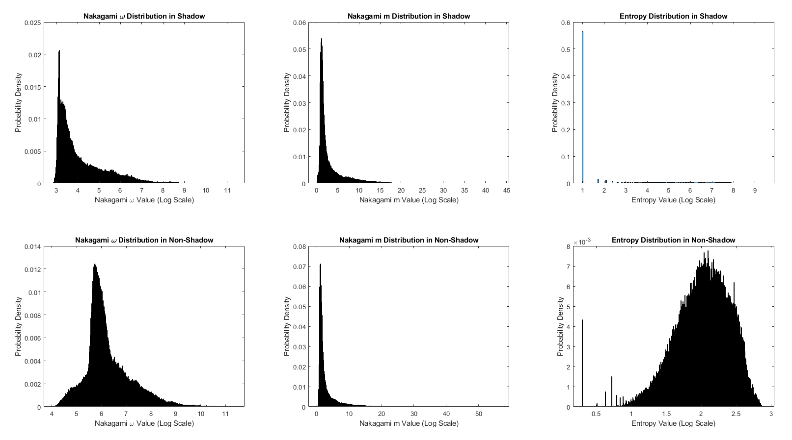

**Added caption:**

**L420:** Histograms of Nakagami parameters and entropy values in shadow and non-shadowing regions. The Nakagami *Ω* has a more noticeable delineation between shadowing and non-shadowing distributions compared to the Nakagami *m* parameter and was used as the only parameter to threshold shadow boundaries. The entropy distributions for shadow and non-shadow differ as entropy is very minimal is continuous dark shadow regions. Although entropy varies in non-shadow regions, thresholding can be used to detect a shadow boundary where at some point along a scanline, the entropy increases above a threshold and remains low afterward to resemble the shadow distribution.

**16.**

**Reviewer’s Comment:**

Acknowledgments: Because the manual shadow detection is your benchmark measure, it is surprising that this was not considered in the authorships.

**Author’s Response:**

The acknowledged trainer was indeed an important contributor and provided valuable from sonography experience. The authorships were determined by any extended effort in data acquisition, novel contributions to the method, and supervision. The acknowledged manual detection trainer did not manually segment the all the images and provided training for two hours to the authors for manual segmentation and was not considered for authorship.

**Changes in Manuscript:**

No changes made regarding this comment.

Responses to **Reviewer 2**

**1.**

**Reviewer’s Comment:**

To improve clarity, I would add flow-charts depicting shadow detection processing for both RF and B-mode data.

**Author’s Response:**

We agree that a flow chart would improve clarity for the readers. A flow chart has been added in Figure 1 in the manuscript to depict the different processing steps for RF and B-mode data.

Changes in manuscript:  
**Changes in Manuscript:**

**L59:** Added “The two methods are illustrated in a flowchart in Fig. 1.”

Added the following figure to manuscript:

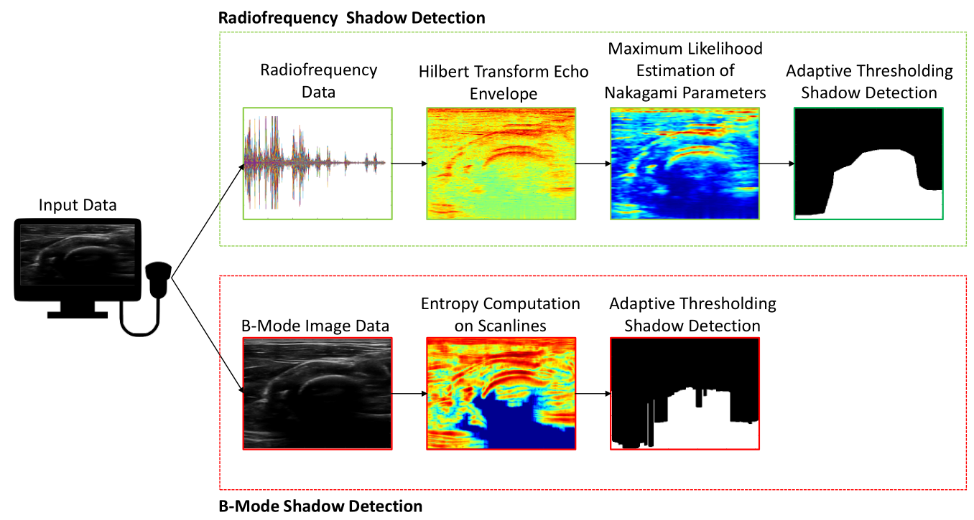

**Added caption:**

**L395:** “Figure 1: Processing steps for Radiofrequency (RF) and B-mode shadow detection. RF processing is used if RF data is available and involves fitting the Nakagami distribution onto the echo envelope of each RF scanline before adaptive thresholding with Otsu’s method. In many cases, there may only be access to B-mode image data, for which an entropy map is computed and similar adaptive thresholding is used to detect shadows.”

**2.**

**Reviewer’s Comment:**

Demonstrating shadow detection performance using suitable phantom data can provide further validation for the algorithms described. The manuscript is good enough without such results, but I suggest adding them if practical.

**Author’s Response:**

Phantom studies do provide extra validation for scenarios where very clear shadows and non-shadow regions are observed, which may be easier for shadow detection than using human anatomy. We agree that phantoms also provide a good baseline scenario with less complexity that human anatomy. With the aim of eventually applying shadow detection in pathological cases, which involves imaging anatomy, we chose to focus resources for studying differing imaging locations and equipment in humans and present the human data in the manuscript.

**Changes in Manuscript:**

No changes made to manuscript.

**Responses to Reviewer 3**

**Note that the response are organized such that all grammatical comments are responded to in a summarized table at the end.**

**1.**

**Reviewer’s Comment:**

Statistical significance via T-test or Wilcoxon not shown for difference between shadow and non-shadow regions (4 in all): "a non-shadow region above the boundary, a shadow region below the boundary, a \transition region", which is a window defined as three pulse widths long axially below the boundary, and a deep shadow region, which is the data below the transition region."

**Author’s Response:**  
We agree that a significance test would be required for the nature of the results. A Wilcoxon test has been performed to investigate if the distributions for shadow and non-shadow regions are statistically different. Results have been report in the result section and distributions have been visualized in the newly added Figure 4.

**Changes in Manuscript:**

**L183:** Added “A Wilcoxon rank sum test has been performed between Nakagami Ω parameter values in shadow and non-shadow regions and between entropy values in shadow and non-shadow regions.”

**L197:** Added “The distributions of Nakagami parameters and entropy for the different regions are visualized in Fig. 4.”

**L202:** Added “Wilcoxon rank sum p values were less than 0.002 between Nakagami Ω parameter distributions in shadow and non-shadow regions and less than 0.001 between entropy distributions in shadow and non-shadow regions, indicating that shadow and non-shadow regions have statistically different distributions for Ω and entropy.”

Added the following figure to manuscript:



**Added caption:**

**L420:** Histograms of Nakagami parameters and entropy values in shadow and non-shadowing regions. The Nakagami *Ω* has a more noticeable delineation between shadowing and non-shadowing distributions compared to the Nakagami *m* parameter and was used as the only parameter to threshold shadow boundaries. The entropy distributions for shadow and non-shadow differ as entropy is very minimal is continuous dark shadow regions. Although entropy varies in non-shadow regions, thresholding can be used to detect a shadow boundary where at some point along a scanline, the entropy increases above a threshold and remains low afterward to resemble the shadow distribution.

**2.**

**Reviewer’s Comment:**

“L21 “Mention the parameter of the confidence threshold”

**Author’s Response:**

We thank the reviewer for this comment as it brings to light that the confidence threshold used by the previous method was a heuristic, which is important to mention. The confidence threshold from the previous method has been mentioned.

**Changes in Manuscript:**

**L21:** Changed “if it is below a confidence threshold” to “if it is below a heuristic confidence threshold of 0.25”

**3.**

**Reviewer’s Comment:**

“L77 speckle is not multiplicative noise but sure it can be described as multiplicative scattering“

**Author’s Response:**

Similar response to Reviewer 1, we agree the multiplicative is not an accurate word to use in describing speckle. We have changed the description of speckle to be related to the randomized distribution from scatterers interacting with an acoustic wave.

**Changes in Manuscript:**

**L80:** “Speckle occurs due to multiplicative scattering of acoustic waves in a material, resulting in a granular appearance on the image.” to “Speckle occurs from interference of randomly distributed microscopic scatterers, resulting in a granular appearance on the image”.

**4.**

**Reviewer’s Comment:**

“L170 statistical significance?”

**Author’s Response:**

Similar to Comment 1, we agree that significance test is required for this data. A Wilcoxon test has been performed.

**Changes in Manuscript:**

The change has been documented in Comment 1.

5.

**Reviewer’s Comment:**

“Minor comment: Discovered a few typos/grammatical errors which have been commented on in the text”

**Author’s Response:**

We thank the review for taking the time to review the manuscript and for the thorough grammatical feedback. Changes made in grammar have been summarized in tabled for convenience below as they are minor and do not require a lengthened conceptual discussion.

**Changes in Manuscript:**

Grammatical Changes:

|  |  |  |  |
| --- | --- | --- | --- |
| **Reviewer’s Grammatical Comment** | **Original Manuscript** | **Changed Manuscript** | **Line Number In Resubmitted Manuscript** |
| Abstract “Significantly different” | “An acoustic shadow is an ultrasound artifact occurring at boundaries between significantly tissue impedances” | “An acoustic shadow is an ultrasound artifact occurring at boundaries between significantly different tissue impedances” | Abstract |
| Abstract “Do not capitalize entropy” | “The fitted Nakagami parameter and Entropy values” | “The fitted Nakagami parameter and entropy values” (note that parameter maintained to be singular because only one of the Nakagami parameters was used | Abstract |
| Abstract “indicates” | “The high accuracy in different imaging scenarios indicate” | “The high accuracy in different imaging scenarios indicates” | Abstract |
| L6 “difficulty” | “that increase the difficult” | “that increase the difficulty” | 6 |
| L30 ‘these techniques” | “The techniques achieved” | “These techniques achieved” | 31 |
| L38 “the capability” | “has demonstrated capability” | “has demonstrated the capability” | 39 |
| L38 “types of anatomy” | “shadow detection from multiple anatomy” | “shadow detection from multiple types of anatomy” | 40 |
| L45 “techniques” | “operator technique” | “operator techniques” | 46 |
| L47 “focused” | “Previous techniques focus” | “Previous techniques focused” | 48 |
| L80 “related to” | “but speckle contains information of the acoustic interactions in tissue” | “but speckle contains information related to the acoustic interactions in tissue” | 88 |
| L89 “capable of” | “The Rayleigh distribution is capable for modeling” | “The Rayleigh distribution is capable of modeling” | 102 |
| L154 “used” | “Ljung-Box Q-test was use” | “Ljung-Box Q-test was used” | 182 |
| L167 “differentiating” rather than between | “the parameters between a shadow and non-shadow” | “the parameters differentiating a shadow and non-shadow” | 198 |
| L176 unnecessary hyphen | “achi-eved” | “achieved” | 212 |
| L192 “indicates” | “the computed Nakagami $\omega$ parameter of all manually outlined shadows indicate” | “the computed Nakagami Ω parameters of all manually outlined shadows indicate”  **Note that instead of changing “indicate” to ‘indicates” (which would be grammatical correct if the noun was “Nakagami parameter”), we pluralized parameter to parameters as the statement should refer to all the Nakagami omega parameters computed** | 228 |
| L321 insert space | “2.50cm” | “2.50 cm” | 409 |
| L326 “similarly” | “perform similar” | “perform similarly” | 415 |